**BIG DATA MINI PROJECT**

**DONE BY L . ANJANEYA VARA PRASAD**

**2320471**

**HADOOP :-**

Hadoop is an open-source framework based on Java that manages the storage and processing of large amounts of data for applications. Hadoop uses distributed storage and parallel processing to handle big data and analytics jobs, breaking workloads down into smaller workloads that can be run at the same time.

**ENTERING INTO HADOOP USING COMMANDS FROM UBUNTU :-**

* Cd – is for changing directory from ubhuntu to hadoop
* We enter into hadoop-2.7.1 then we make ready for daemons using sbin/start-all.sh
* Check the daemons using jps command, it will show 6 deamons running.

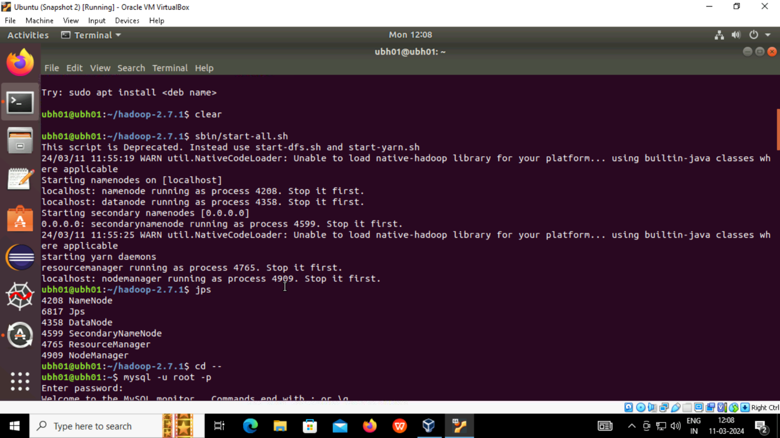

**ENTERING INTO MYSQL USING FOLLOWING COMMAND**

* Now use mysql -u root -p command to enter into sql shell and then start writing sql command for creating table and inserting values into it

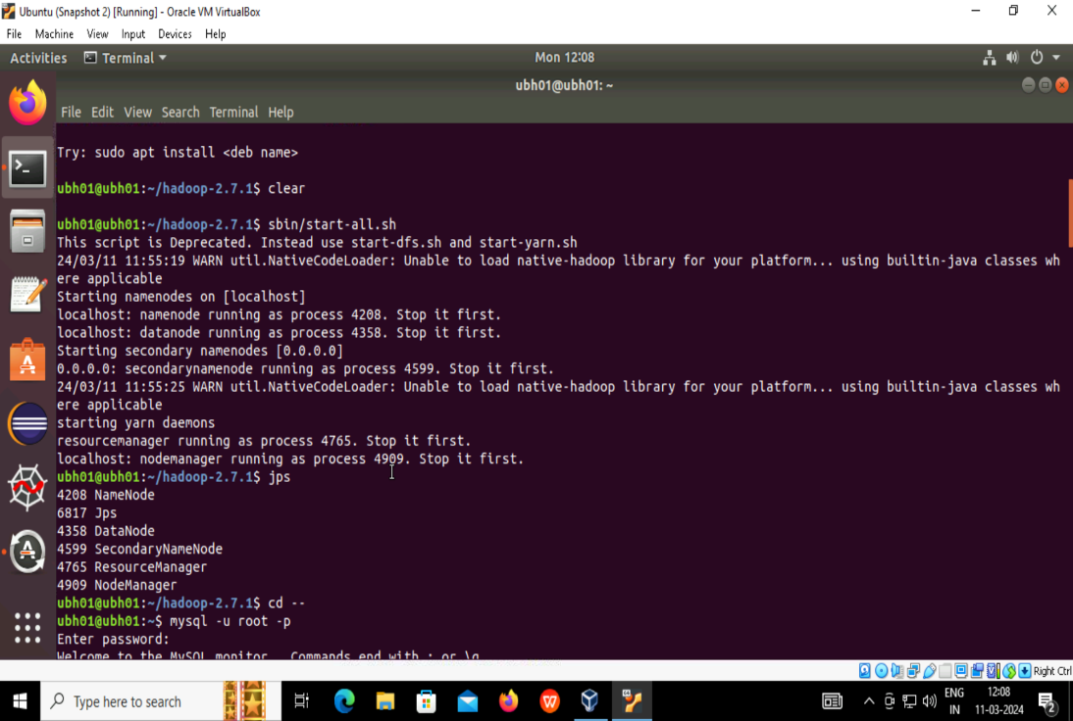

**CHECKING AVAILABLE DATABASES:-**

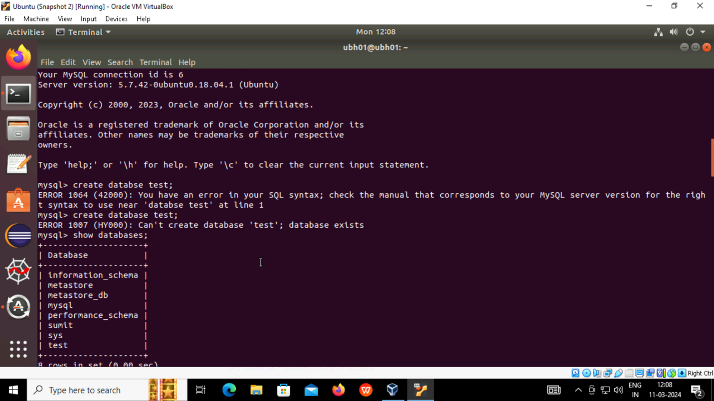

* We created table using create table table name and insert into table with values

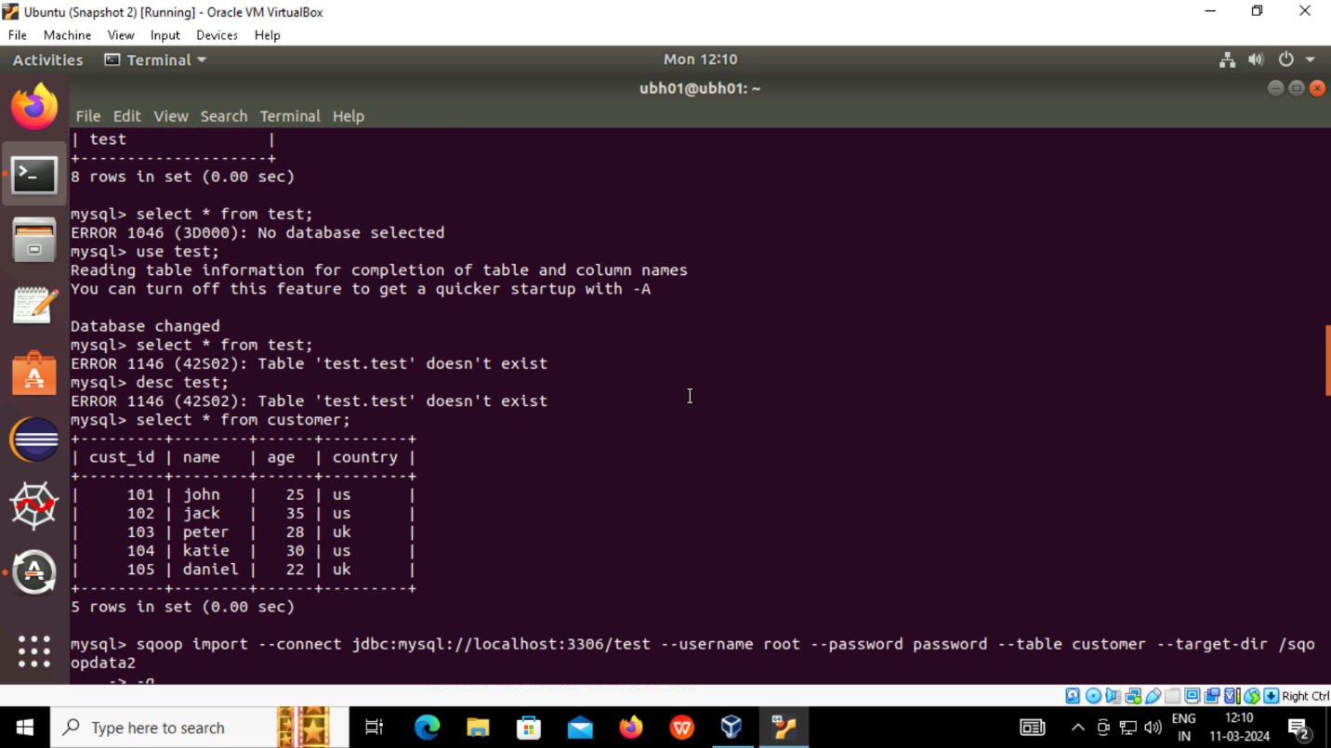

**SQOOP IMPORT**

* Apache Sqoop, a command-line interface tool, moves data between relational databases and Hadoop. It is used to export data from the Hadoop file system to relational databases and to import data from relational databases such as MySQL and Oracle into the Hadoop file system.
* using sqoop import command we will connect to jdbc and we will give username and password then target directory to hdfs file,where we want to import our data

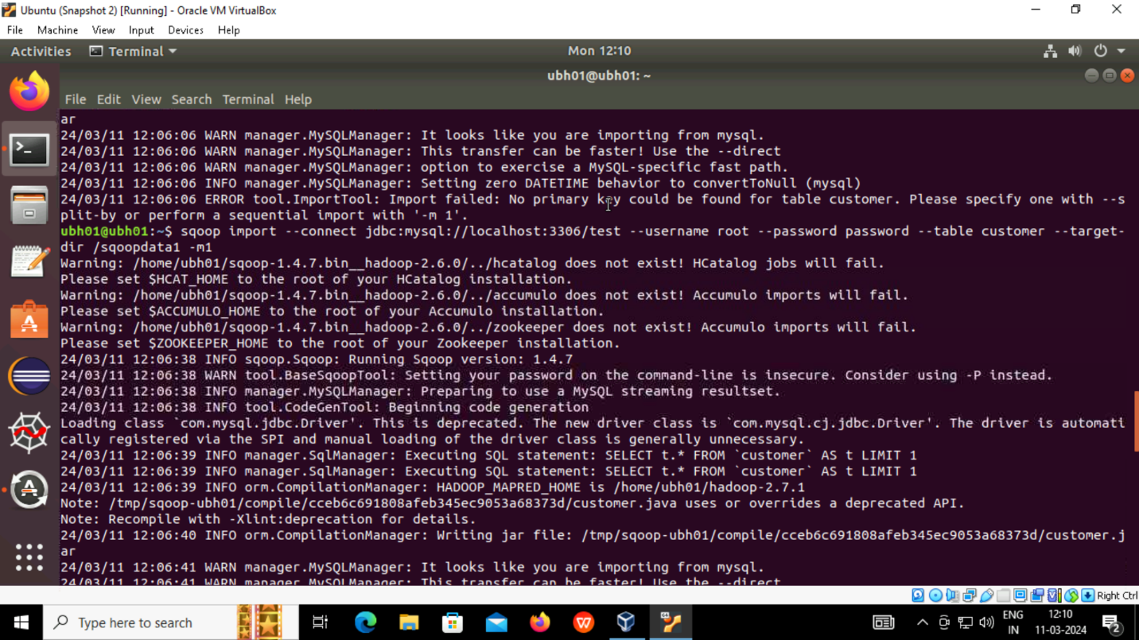

**Sqoop import provided with no.of mappers:**

* We need to give the number of mappers needed to complete the work as -m1 or -m2 according to to requirement as there is no primary key, we should give no. of mappers as -m

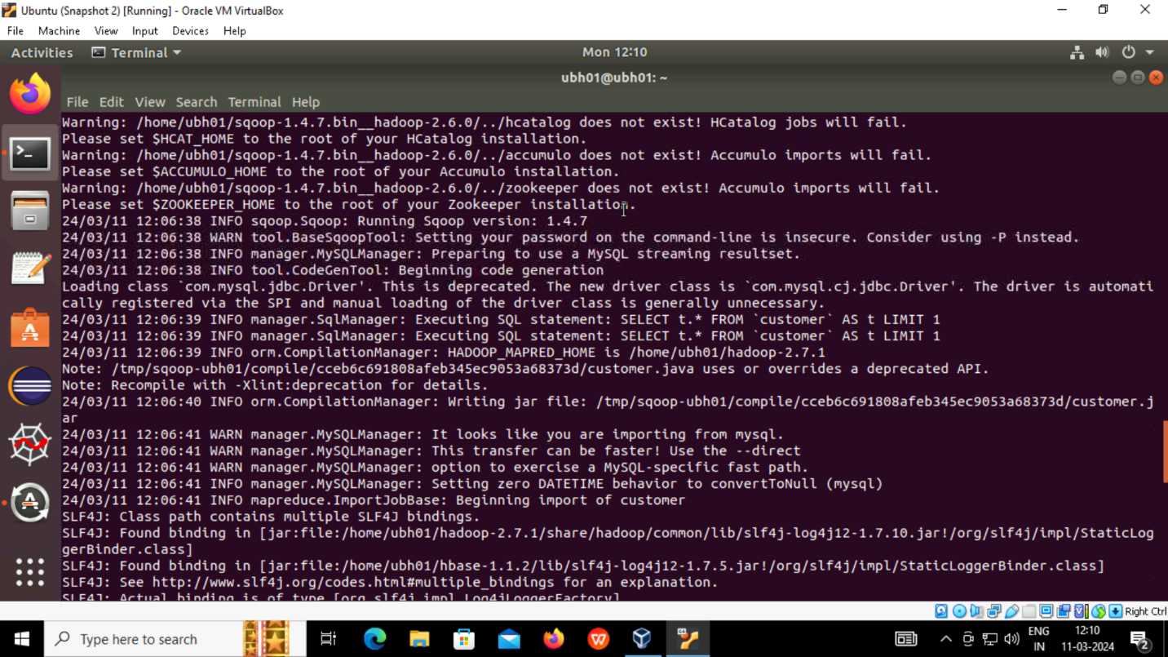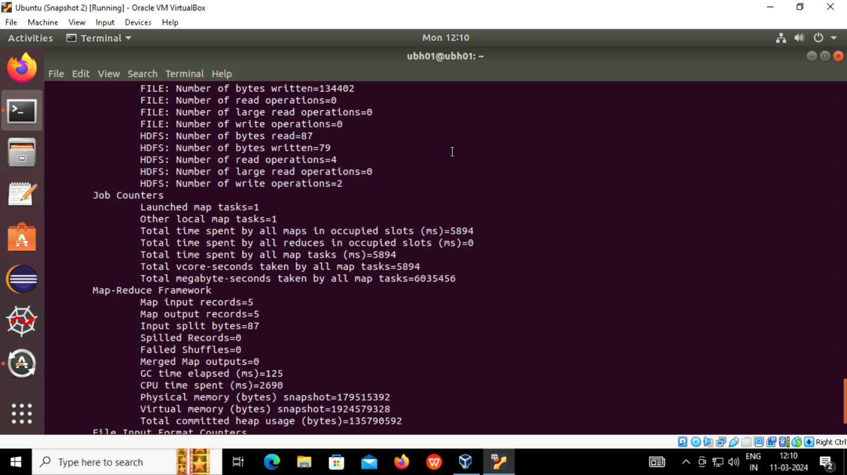

* It will import data from rdbms to hdfs using sqoop import command.
* COMMAND used in sqoop import is given below
* **sqoop import –connect jdbc :mysql://local host:3306/test –username root –password password –table customer –target-dir /sqoopdata1 -m1**

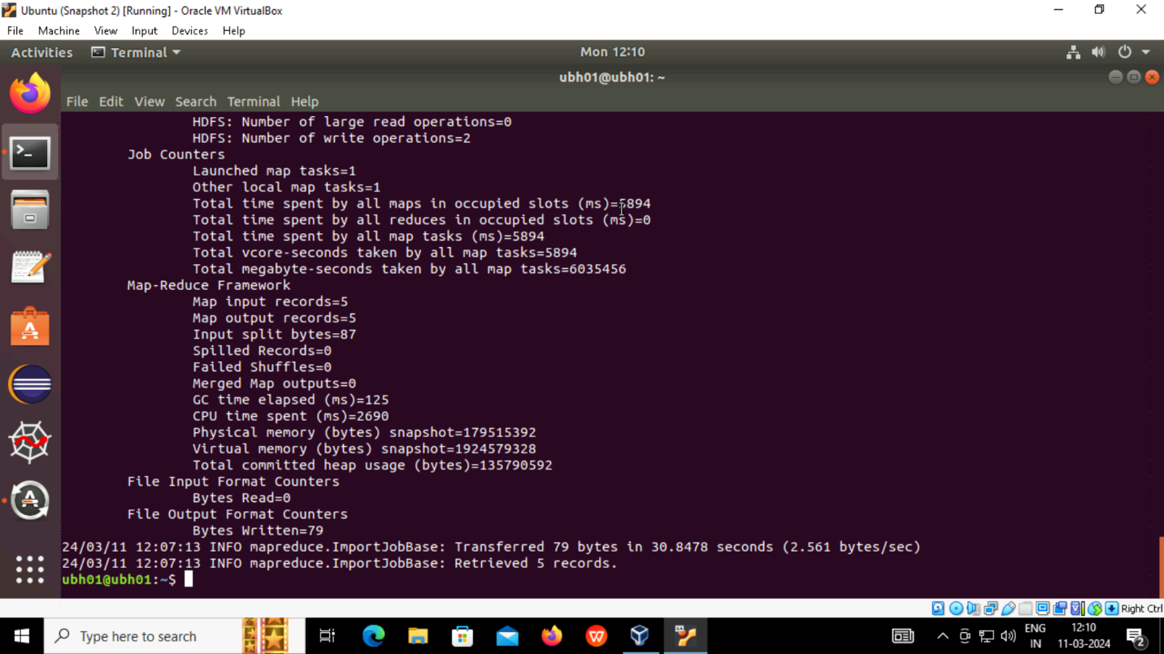

**Hdfs dfs -ls / :-**

* To view the files inside the directory we use -ls / . “/” is the start path of directory
* Here sqoopdata1 is the name of hdfs file and inside that we check the contents.
* Using part* we retrive data using hdfs dfs -cat / command

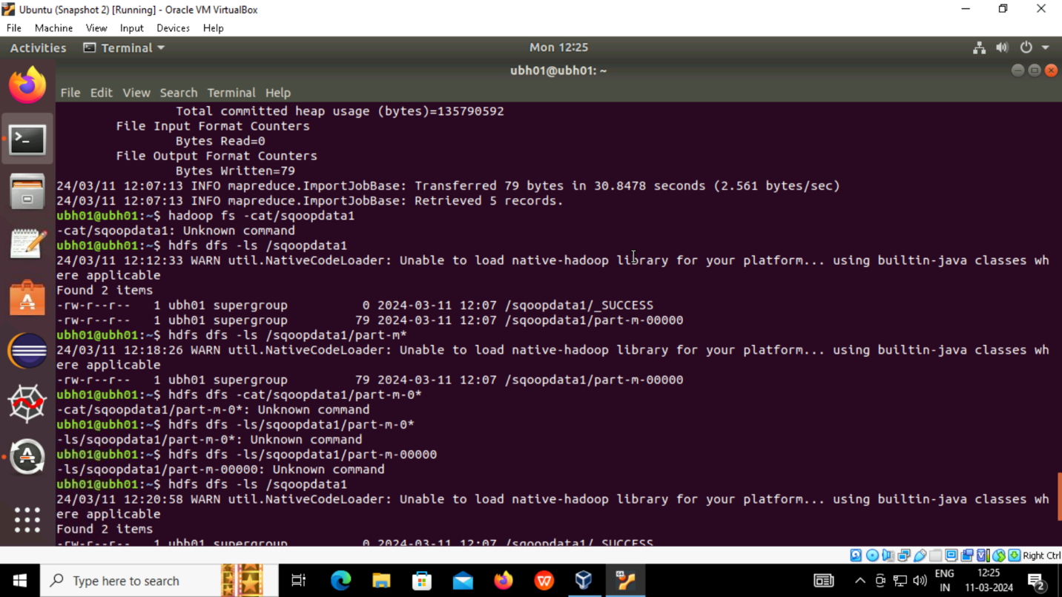

* The contents in rdbms or the table we created in mysql is now can be seen in hdfs using cat command

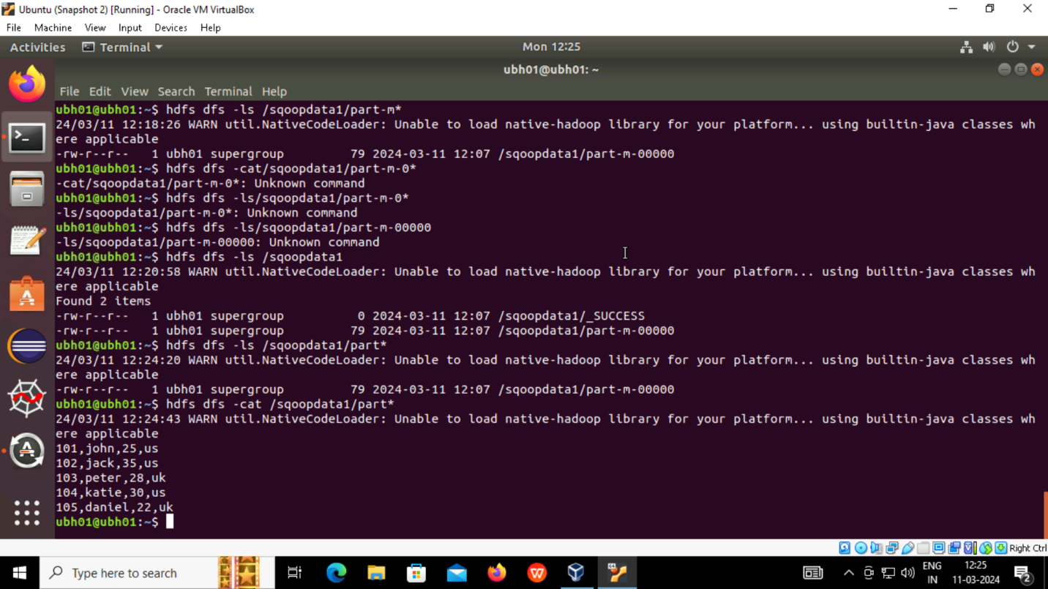

* Here we can write where in btw the sqoop command to retrive specific data. In my case I want data where country should be “US” . Now only data with US are imported into hdfs from local or rdbms or mysql.

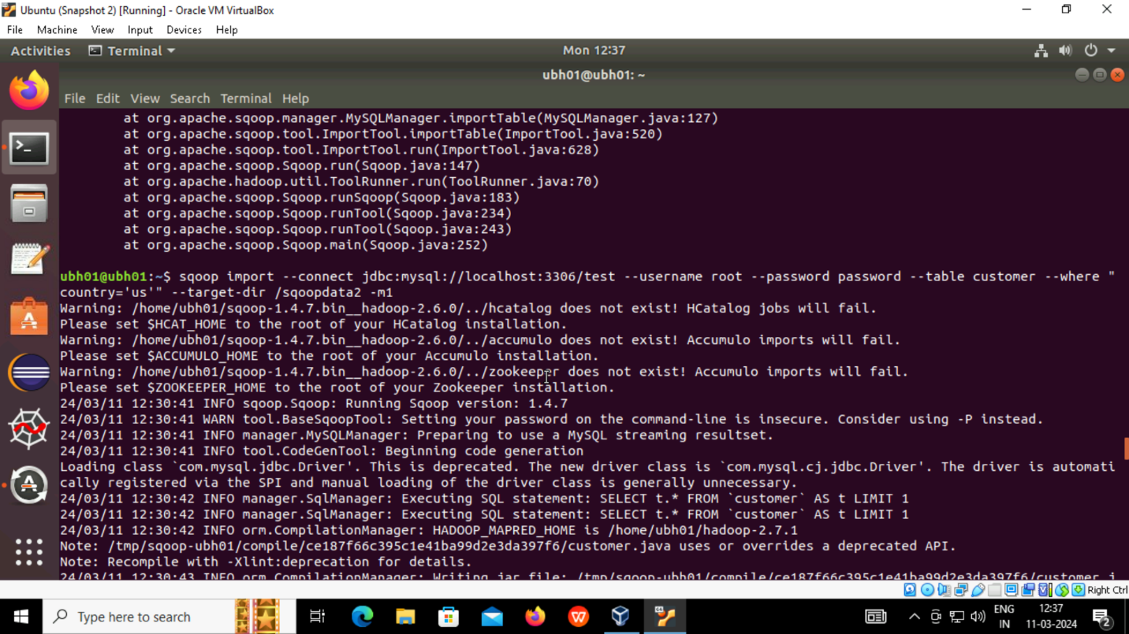

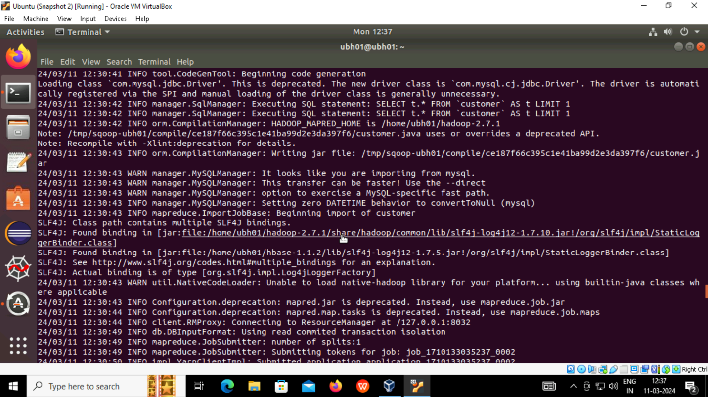

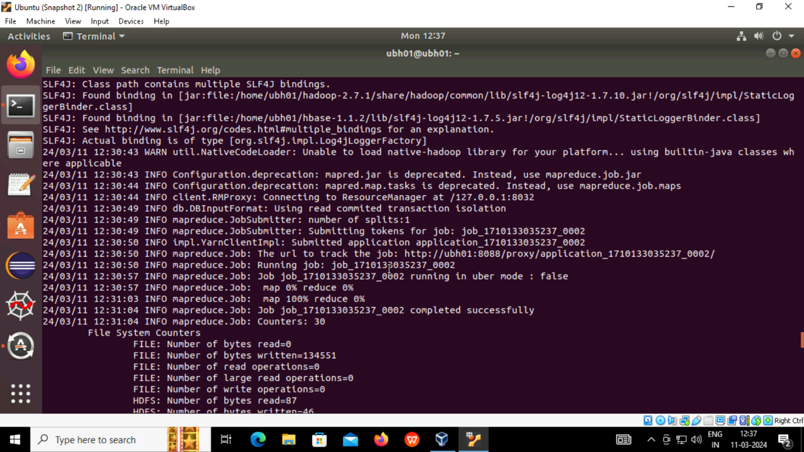

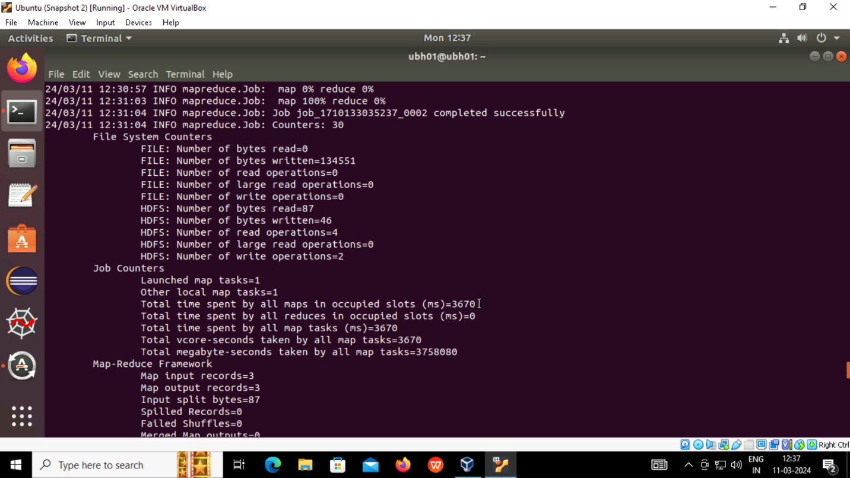

**QUERY IN SQOOP:-**

* We should mention query “select * from table_name and where condition and \$CONDITIONS to import particular data using select statement .we say sqoop to allow sql commands by mentioning the sql commands with ‘’QUERY”.
* SPLIT-BY column name is used to say the query that we say use this particular column to split the data into chunks for parallel processing and to increase data efficiency and scalability

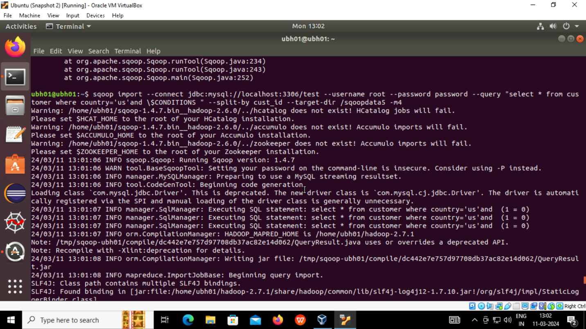

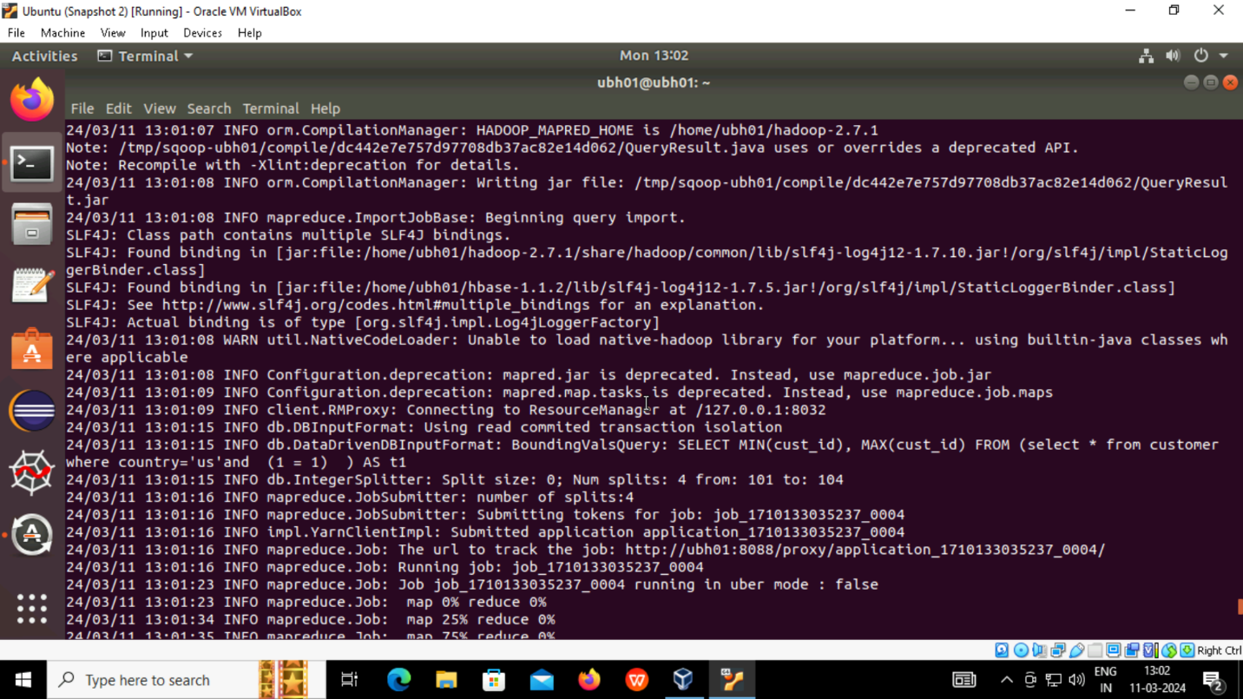

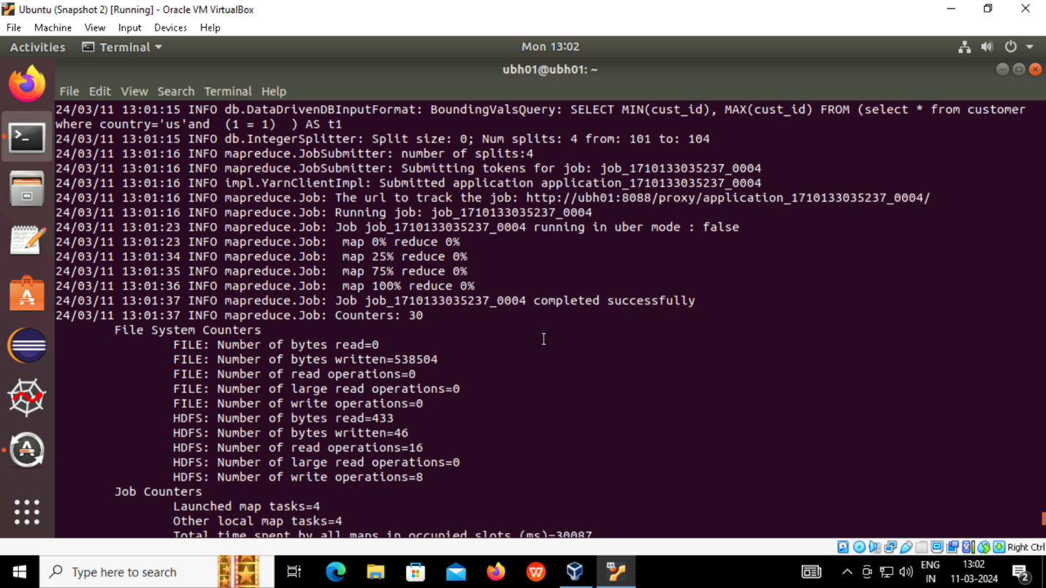

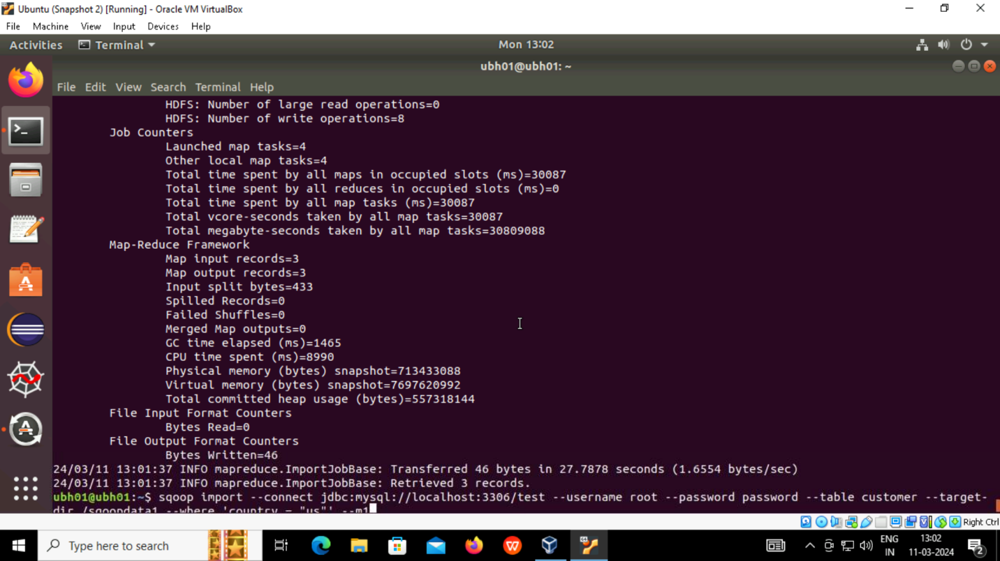

* To check whether the data from rdbms is imported to hdfs or not
* We type hdfs dfs -cat / to display the contents

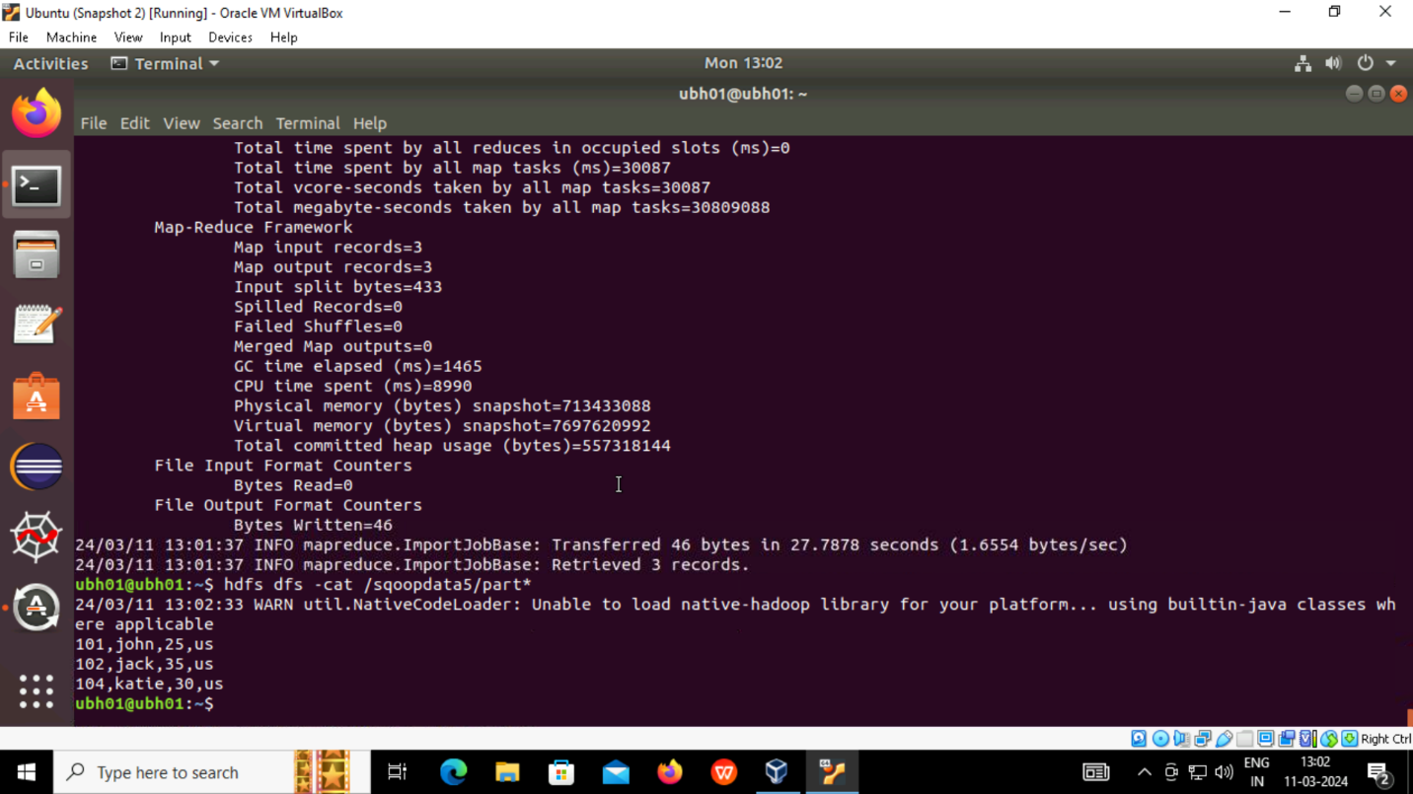

* USING --as-avrodatafile command in sqoop import command we can change the file type and is imported to hdfs as avro datafile (ex:- --as-parquet , --as-textfile )

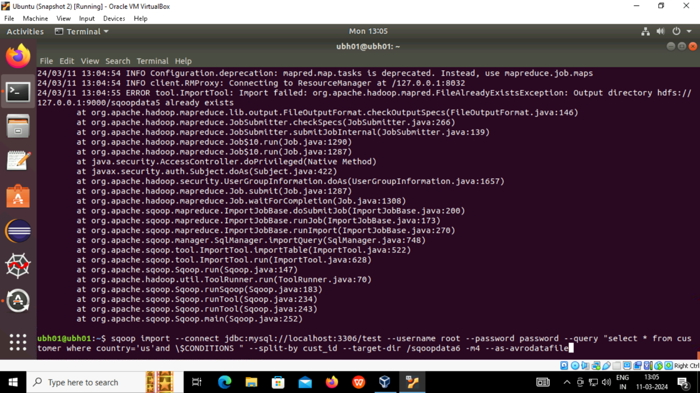

* **apt-get update -y** is used to get all the packages with updates on using -y as “yes” for all the permissions required.

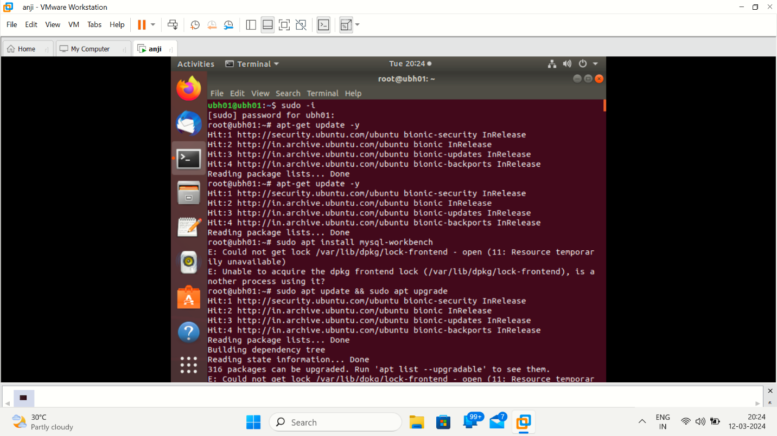

**Loading data into mysql table:-**

* We create a table and then we will load data using command load data infile “/local path” into table table_name
* Fields terminated by “,” lines terminated by “/n” ignore 1 rows is to remove header column.
* Mysql will not allow to load data because it is secured , to check with that we write show variables like “secure_file_priv”;
* It will show the default file as **/var/lib/mysql-files/**
* So we will copy our local file to this default file for security issues

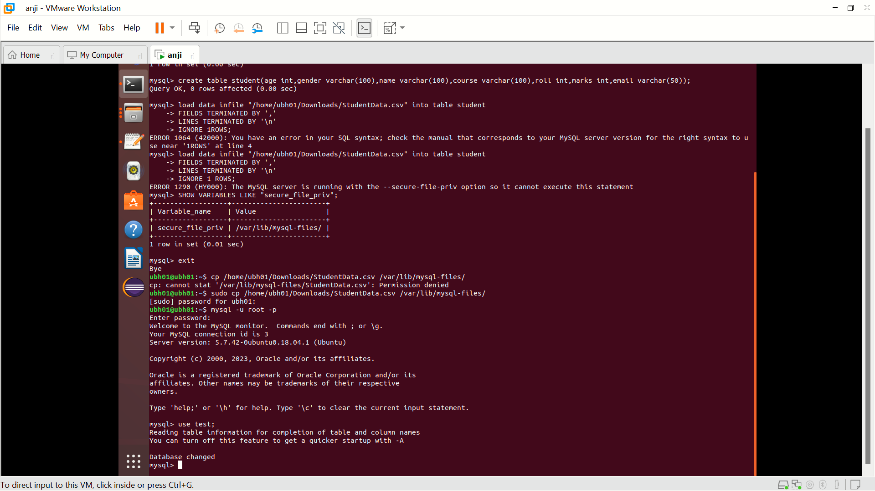

* Now we load data using the command
* **Load data infile “var/lib/mysql-files/StudentData.csv” into table tablename fields terminated by ‘,’ and lines terminated by ‘\n’ ignore 1 rows;**
* loading is done and retrived using select statement.

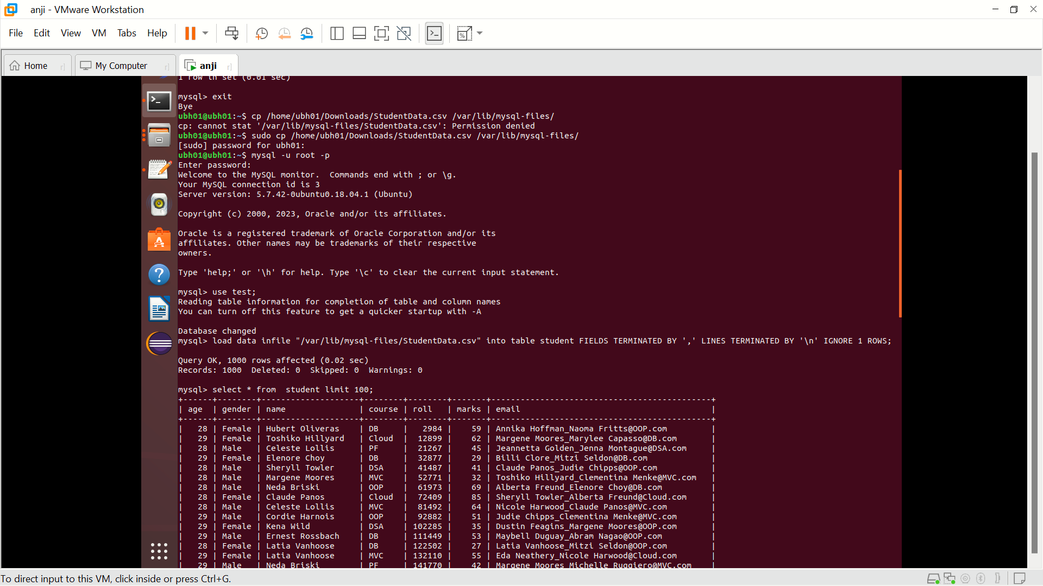

**Sqoop import:**

* Now the data is imported from mysql to hdfs using sqoop import command
* Then from hdfs path we can load data into hive using load data inpath ‘hdfs path’ into table name

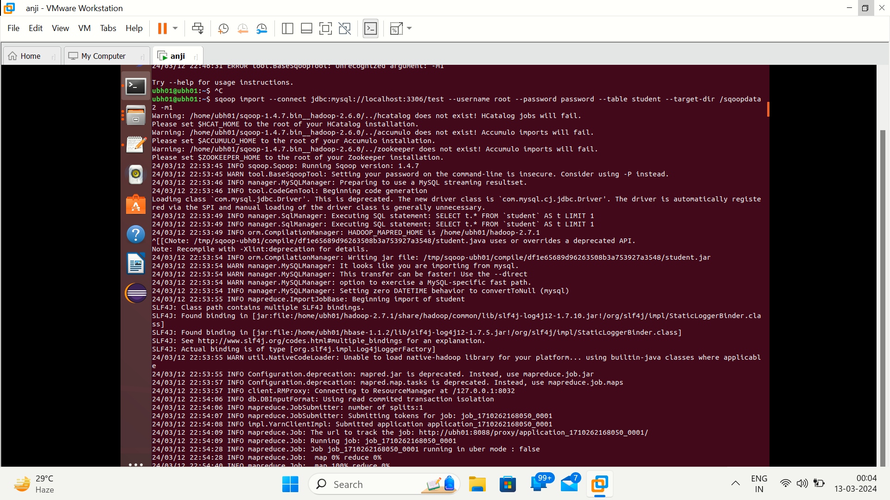

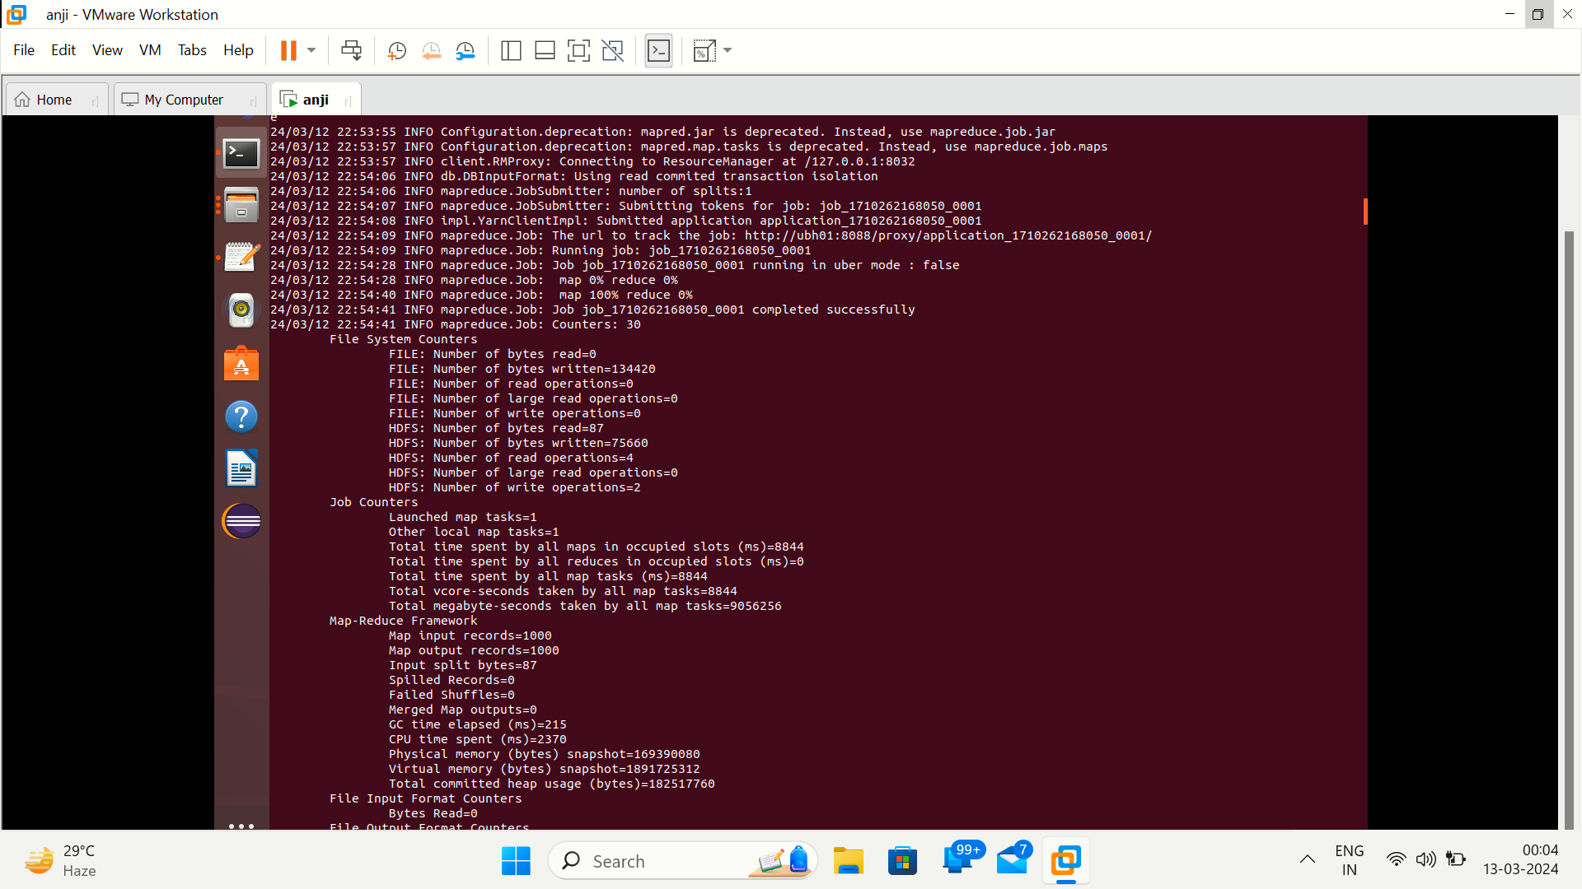

**Hive:-**

* Hive is a data warehouse system that is used to query and analyze large datasets stored in the HDFS. Hive uses a query language called HiveQL, which is similar to SQL. As seen from the image below, the user first sends out the Hive queries
* We will enter into hive using hive command and we will create a database and then a table with the same scheme of what we try to load

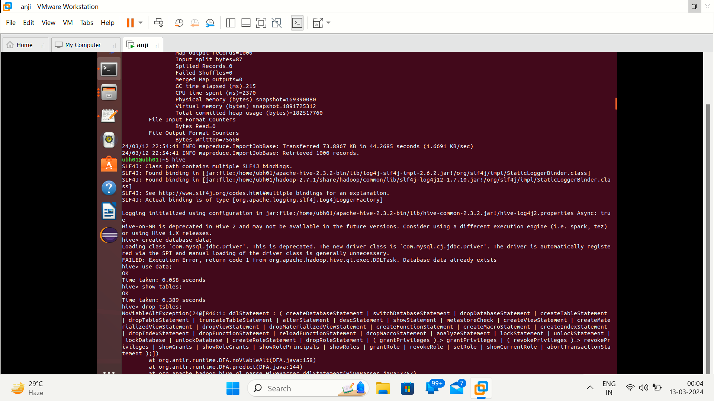

* We will create database and table in hive and then load data into table using load data commands
* We created nandan table and loading data form local to hive

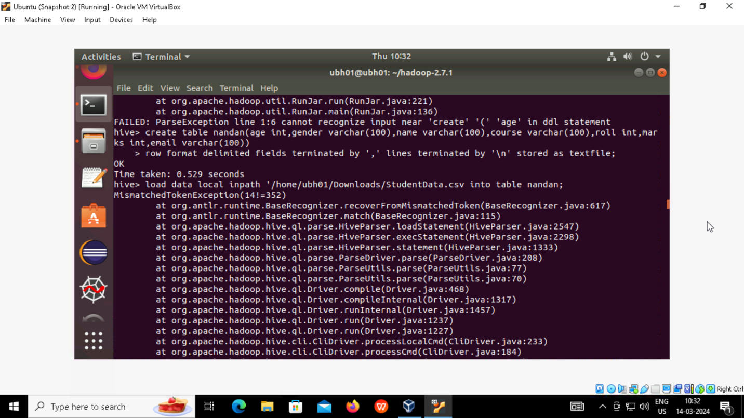

* we created table and load data using local inpath (local to hive)

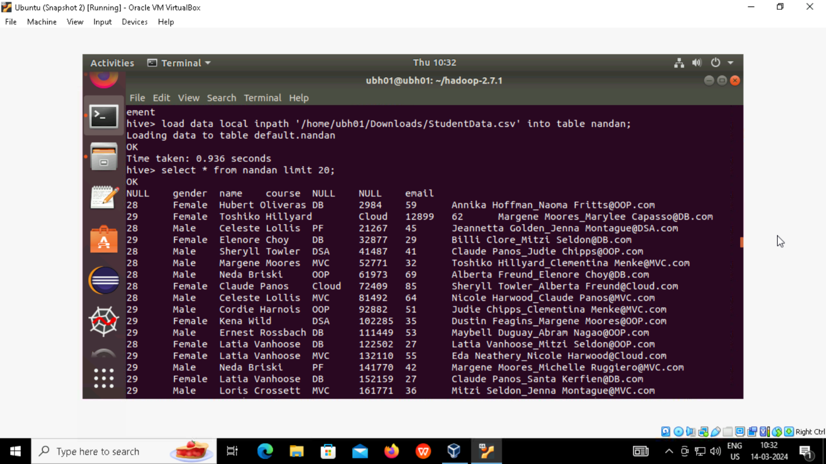

**Create table static partition and then load data using insert**

* We can’t load data directly into a partition table so we use select from non partition table and insert data into partition table

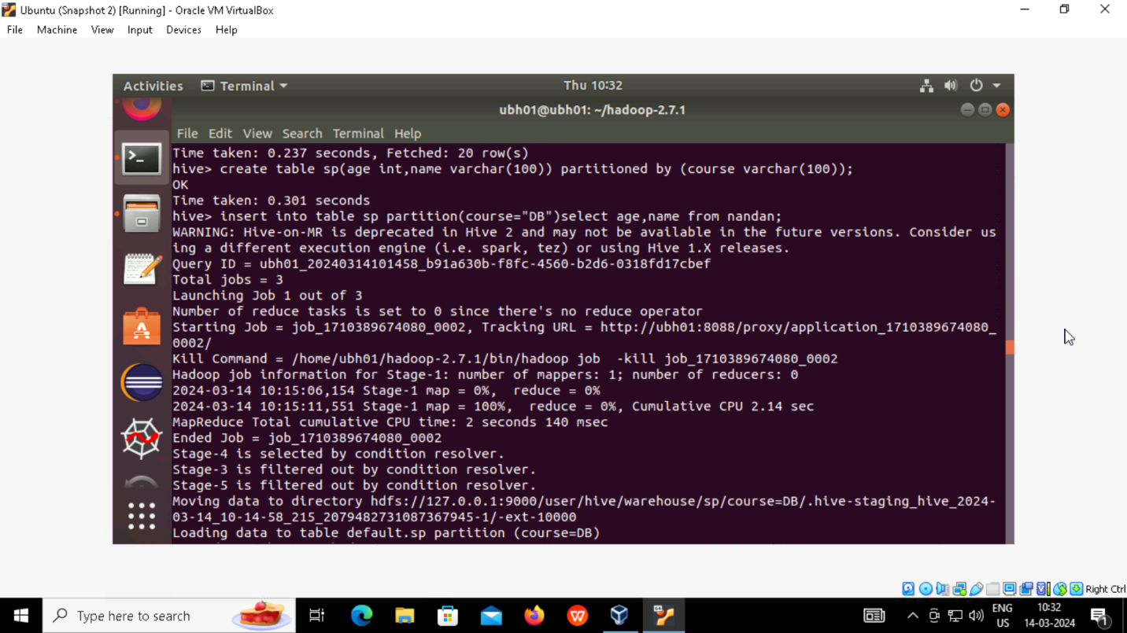

* Select * from sp ,then we can see data is loaded into our partitioned table where course is our partitioned column

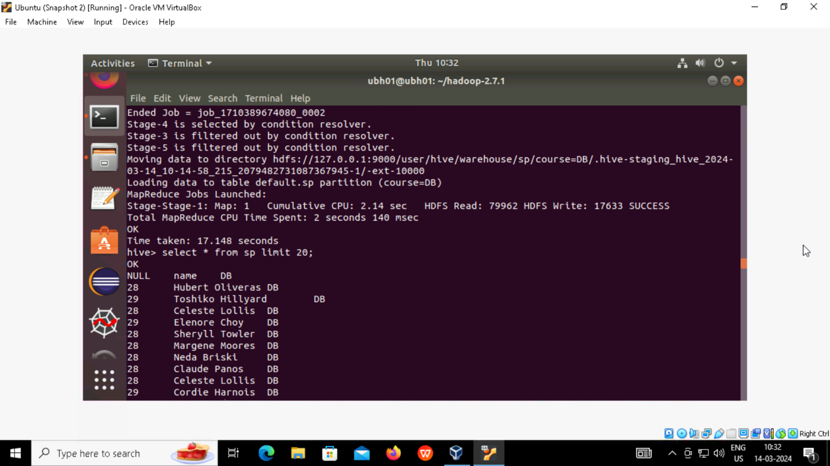

**Creating dynamic partition**

* Create table and this is dynamic partitioned is same as static but inserting makes the difference

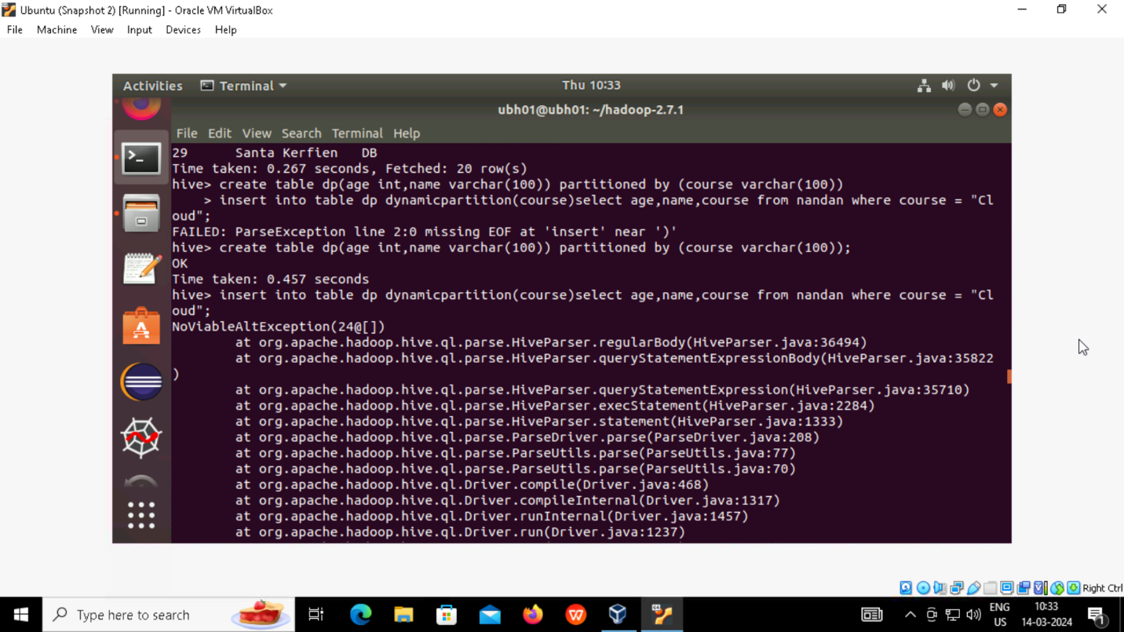

* **Set hive.exec.dynamic.partition.mode = nonstrict**
* As hive as some restrictions in creating dynamic table we need to set it to nonstrict

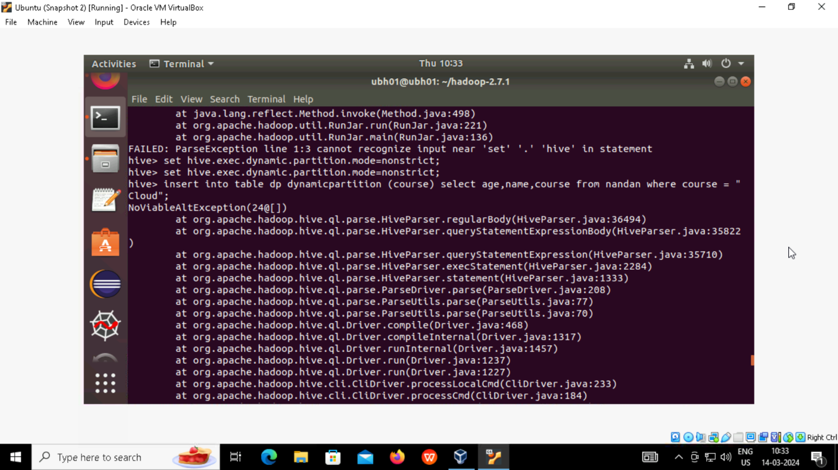

* Insert into table ,here we don’t write course value instead we write where conditions In select statement according to user

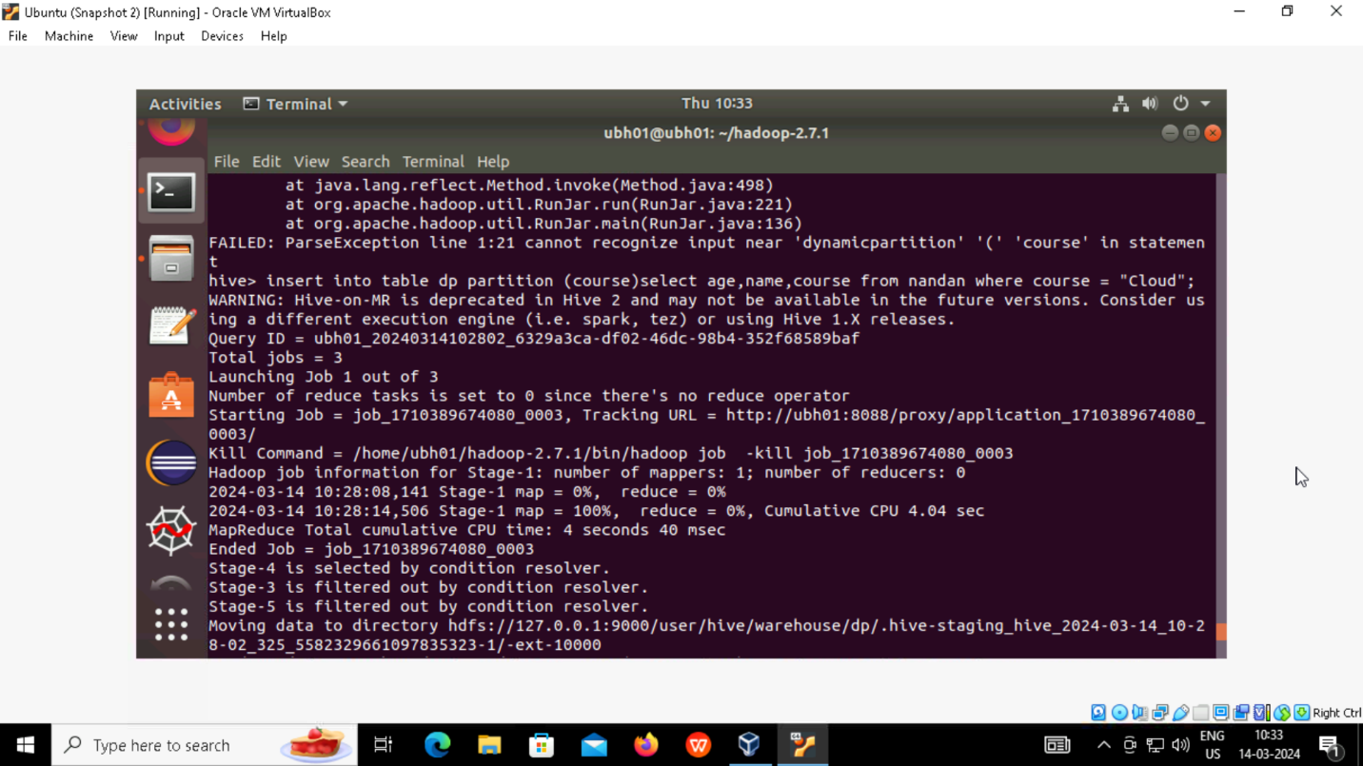

* Select * from tablename to check the contents

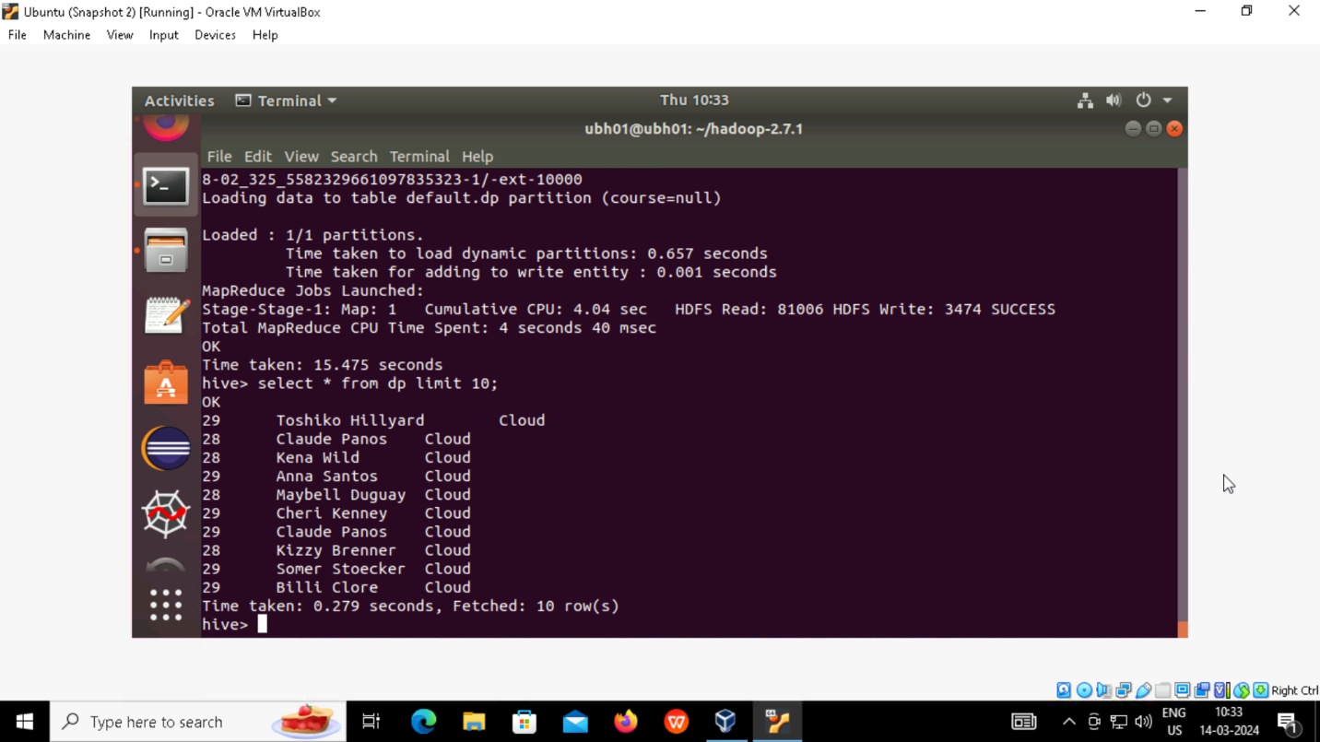

**Bucket creation**

* Create table tablename and clustered by columnname into no of buckets stored as textfile

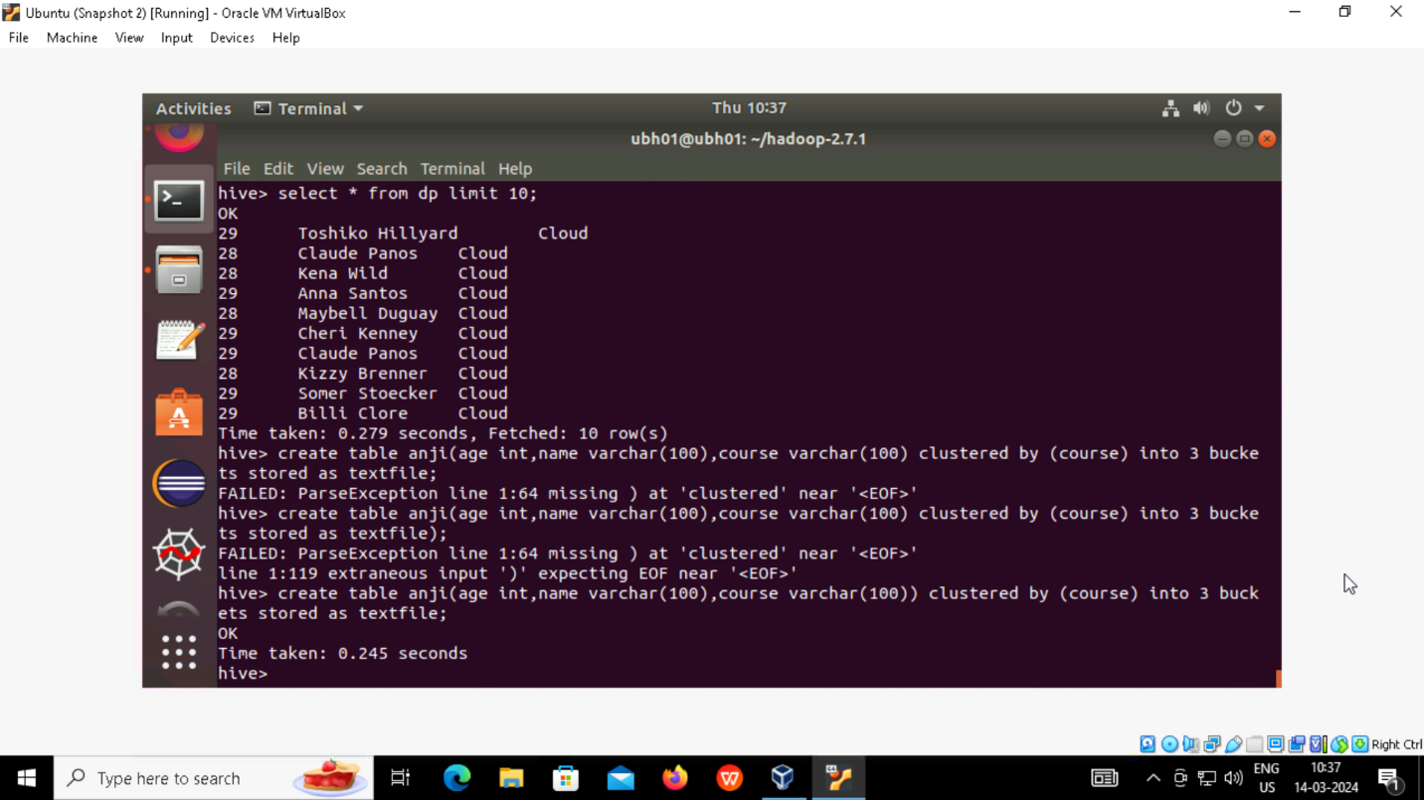

**Insert into table using select from non partitioned table:-**

